In partial fulfillment of the requirement for

System Development

420-940-VA section 05808

Vanier College

Client and Business Domain

2nd Deliverable

Customer Name:

Delhi Kabab

Team Name:

Green Team

Team Leader:

Shayekh Tarafdar

Team members:

I, Lei Wang, ID: 2295046, certify that I contributed to this deliverable



I, Bing Bai, student ID# 2295011, certify that I contributed to this deliverable

I, Shayekh Tarafdar, student ID# 2295035, certify that I contributed to this deliverable

I, Md Ibrahim Ullah, student ID# 2295025, certify that I contributed to this deliverable



I, Bermet Doolbekova, student ID# 2295017, certify that I contributed to this deliverable

I, Mark Benedict Muyot, student ID# 2295022, certify that I contributed to this deliverable

Date of Submission:

September 26, 2022

**TABLE OF CONTENTS**

1. Statement of Previous Work Experience…………….………………….3

2. Executive Overview………………………………………….……..…........4

3. Business Domain …………………………………………………………...5

4. Business Environment……………..…………………...……..……..……...7

4.1 Environment………………………………………...…….............…7

4.2 Website and Social Media………………………………….….….....7

4.3 Competitor……………………………………….……….……....….7

5. Description of Client ………………………………………….…………... 8

6. Business Problem ……………………….………………………….….... ...9

7. Open Questions………………………………………………………….…10

8. Questionnaire………….………..…………….……………………….........11

8.1 General Questions………………………………………….…….. ...11

8.2 About the System……………………………………..………..........11

9. References……..………………………………………………….….…......13

10. Appendix A: Photos …….. ………….………………………………....….14

11. Appendix B: Website Screenshots………….…………………………..….15

**1. STATEMENT OF PREVIOUS WORK EXPERIENCE**

For the projects we have done in previous terms, our team members employed certain skills in gathering information of some specific businesses. For example, in order to design a database for a car rental company, some searched and analyzed the car rental business. However, the experiences are only limited within the realm of desktop research. None of these projects involved a designing a questionnaire.

Table 1: Prior projects with similar experiences in Deliverable 2

|  |  |  |
| --- | --- | --- |
| **Projects Made** | **Skills** | **Contributor/s** |
| Cars2Go Database | Desktop research | Everyone |
| Online Grocery | Desktop research | Bing Bai |
| Hotel Reservation | Desktop research | Lei and Bermet |

**2. EXECUTIVE OVERVIEW**

In the phase of deliverable 2, the team focused on researching our client, Delhi kabab, an Indian restaurant located in Montreal south shore. By collecting and analyzing our client’s external business information, we come to understand the context of their business problems and draft a questionnaire aiming to exploring the details of their inventory system for next phase.

The research begins with the investigation on our client’s business domain. Delhi kabab, like many other Indian restaurants in Canada, serves curries and breads, particularly the specialties from New Delhi. Due to the booming of South Asian immigrants in recent decades, and widely acceptance of Indian food from locals, Delhi kabab wins popularity for serving fine Indian cuisine. However, like most of businesses in catering industry, our client also suffered loss during covid-19 pandemic.

Zooming into their business environment, our team finds that this restaurant boasts a good location with high pedestrian traffic. The restaurant has website and social media presence. The reviews from the customers are overall positive. The fact that few competitors in the area is another favor to the restaurant.

Combining the details of exploration on our client at phase 1, our team has identified that the inefficient inventory system that is currently being used is a business problem that we can tackle. The restaurant is using Excel monitoring sheet to track the inventory, but it often leads to inconsistent information, which results in food spoilage and loss.

Lastly, based on the data collected so far, we designed a questionnaire with a series of open questions concentrating on restaurant’s inventory system. The work completed on this stage will build a solid foundation for use cases and UML design in phase 3.

**3. BUSINESS DOMAIN**

Indian cuisine is a more recent addition to the Canadian culinary landscape. It rose to popularity mostly because of immigration in the years after the 1960s. It is mostly recognised for its Northern Indian cuisine, which emphasises warm curries and breads, as well as the use of yoghurt and cream in dishes with meat as the primary ingredients (Sundarsingh, 2017).

Indian food is widely available in Canada's largest cities. Many South Asian immigrants opened restaurants and other culinary companies when they arrived because of the growing interest in multiculturalism, the freedom of newcomers to maintain their heritage, and the desire to achieve economic security (Sundarsingh, 2017).

A close look of the Indian restaurants show that the industry has benefited greatly from an increased acceptance of Indian cuisine in the mainstream food industry. Since India has many states and different cultures, customers have opportunity to taste many different types of food (Srinivas, 2011).

Most Indian Restaurant here in Canada serves **breads and curries such as palak paneer, aloo Gobi and Tandoori chicken. Also, specialties from New Delhi such as Samosa, Poori Aloo, rolls and Khichri with Sabzi. There are also some restaurants that serves South India’s cuisine which are known for creating amazing spicy dishes such Kozhikode Biryani, Fish curry, Vindaloo and Andhra Chili Chicken.**

Nowadays, most Indian Restaurants like our client Delhi Kabab serves alcoholic and other beverages as a means of generating more revenue and maximizing profits. Other Indian restaurants here in Canada offers casual dining or fast-food style of service (Delhi Kabab, N.D).

Economically, restaurant businesses suffered enormous losses due to increase in inflation rate. In fact, Quebec restaurants are closing faster than they're opening at the same time as diners are spending more money than they were pre-pandemic. Restaurants Canada (RC) report shows restaurants across the country closing at a much faster rate than they are opening, and Quebec's eateries are at the top of the list. Restaurant closures in the country outpaced openings by 43 per cent. In Quebec, 817 restaurants have temporarily closed between April 2021 and July 2022, and 760 restaurants have permanently closed their doors, according to the report. During the same period, 279 were newly opened and 306 re-opened (Rowe, 2022).

When it comes to technology, some Indian restaurant like Bombay Express which can be found in UK adopted new technology in preparing their dishes. They built what they call “smart food experience” . The restaurant makes use of a Rational iCombi Pro and iVario Pro, which reduce labour and allow it to achieve the same output as a much larger kitchen in a fraction of the time. This technology reduces the amount of time in preparing the food. For example, preparing a day’s worth of onion gravy used to take two and a half hours with iVario Pro they can do it in an hour and a quarter. (Seymour, 2022).

Here in Quebec, there are a few Indian restaurant chains like Spicebros and Star of India. Most restaurants here are independent and family-owned restaurants.

Very few Indian restaurants here in Quebec use order and pay at the table system technology, handheld point of sale system, however, contactless payment, and providing digital receipts are almost available in every restaurant including our client.

**4. BUSINESS ENVIRONMENT**

**4.1 Environnent**

Delhi kabab is a business-to-consumer (B2C) type company. It is a cozy, sit-down Indian restaurant located at 6185 Taschereau Blvd., Brossard, Quebec. Since it is located in front of terminus Panama and situated on one of the major routes in South Shore, foot traffic in that area is high which is good for the business. The restaurant is also connected to a strip mall with a lot of parking spaces. They also have a visible signage that is visible from the outside especially at nighttime. The restaurant can fit 40-50 customers at the same time. It can cater to small gatherings or events such as birthday, reunion, etc. They are open everyday from 4:00PM- 9:00PM (**see Appendix A**).

**4.2 Website and Social Media Presence**

The restaurant has an informative and user-friendly website where in you can checkout their menu and make an order online. The website also shows information about the restaurant, photos, and contact details **(see Appendix B).** They also have a strong social media presence as they maintain accounts in Facebook, Instagram, Yelp, and TripAdvisor. (Delhi Kabab, N.D).

Delhi Kabab is rated 4.5 out of 5 in TripAdvisor. Customers have a lot of good comments about the restaurant. The restaurant uses their social media platforms to reach more customers and for advertisement (Delhi Kabab, N.D.).

**4.3 Competitors**

They have few competitors within the area that serve different cuisines like Scores, Sushi Shop and General Tao Restaurant. There are 2 Indian restaurants located approximately 1.3km away from Delhi Kabab, Le Tandoor and Shaan Tandoori. (Google Maps, 2005).

**5. DESCRIPTION OF CLIENT**

**5.1 Description**

The Team’s client, Delhi Kabab, is an Indian restaurant located in Brossard. It is a cozy, sit-down restaurant plating tandoori chicken, spicy curries, and traditional Indian dishes (Delhi Kebab, n.d.). This fine Indian cuisine also serves variety of French food and various delicious desserts. The business is being operated by two partners with 6 employees. This business has been operating for more than 5 years. The restaurant is open everyday from 4:00PM till 9:00PM, they have their own delivery service, and they also are using 3rd party delivery services such as Doordash, SkipTheDishes, and Uber Eats **(see Appendix A).**

**5.2 Computer Skills and Literacy**

The owners can perform basic tasks on the computer. This includes navigating browser, operating system, and using some applications. For the past 5 years, the owners use Windows Operating System and Microsoft Excel in keeping track of work schedules, employees’ salaries, and for their inventory.

The restaurant also has a strong social media presence. They know how to use these platforms.

**6. BUSINESS PROBLEM**

Delhi Kabab has an inefficient system in monitoring their inventories. The restaurant is using a notepad to list necessary items to be ordered such as ingredients for their food preparations, cleaning items, toilet supplies etc. According to the client, they often lose their list and sometimes forget to update the list of ordered items in their system. In consequence, the restaurant's inventory record often produces inconsistent information. This type of system leads to increase in spoilage and loss if inventories like ingredients are not tracked and monitored properly. The system also takes a lot of time tracking and reviewing their inventory. There is no way to view a comprehensive report easily, such as the ingredient supply level.

Customer satisfaction is sometimes affected by the inconsistencies in their inventory management system. There are times where customers want to order something, but the food is not available because some ingredients are missing. This leaves unsatisfied customers which could affect the bottom line of the business.

**7. OPEN QUESTIONS**

When it comes to Delhi Kebab’s inventory management system, the team is aware that there is an inefficiency when it comes to their inventory management system. Their system is also unsecured since they just write down in the notepad when they order their supplies or ingredients. However, the team is not fully aware of the detailed step by step process of Delhi Kabab’s inventory management system. Our team also wants to know if the restaurant has encountered other problems like pilferage due to poor tracking of inventories, spoilage of raw ingredients, etc. We also want to know who, the staff involved in their inventory management.

In addition, the team would also know further about the business. Knowing their future plans like branching out or having the restaurant franchised in the future. This would be helpful for the team designing a flexible system for the client.

Lastly, our team wants to have an insight if there are other processes that are needed to be streamlined within this organization.

**8. QUESTIONNAIRES**

**8.1 General Questions**

1.) Could you tell us something about how you started the business? What was the inspiration behind Delhi Kabab?

2.) Do you have any plans branching out or opening your restaurant for franchise in the future? If yes, what is your target number of branches and location?

3.) Who do you consider as your primary competitors?

4.) Could you describe how many customers on the average eat at your restaurant and make orders for delivery per day?

5.) Do you have any computers you use within the restaurant? If yes, where do you use it for and could you also state the specifications of the computer system you are using?

6.) Do you have a Wi-Fi in this restaurant? If yes, is it available to the customers?

7.) How can you keep up with the raising cost nowadays due to high inflation rate?

8.) How many employees do you have? What are their roles? Could you also tell us something about your employee turn over rate?

**8.2 About the system**

1.) Could you discuss us the step-by-step process on how you do your inventory management? With this system, what are the problems you encountered before and how did you manage to fix it?

2)Have you encountered spoilage of food due to poor tracking or monitoring? If yes, could you elaborate and discuss it briefly.

3) Where do you buy all your supplies or ingredients and how frequent do you order your supplies?

4)What are the inventories you track in your inventory system? How do you track your inventories and how often do you monitor them?

5) Since your inventory management system is not automated, do you think this system is secured? Is pilferage a concern in this restaurant? If yes, how do you manage it?

6) Did you ever consider automating your inventory management system before? If yes, what are the reasons why it didn’t materialize?

7) Who are the people in charge with you inventory management system? Do all of them has the same access level in the system? Could explain the roles or tasks of the people involved in your inventory management system.

8) Besides your inventory system, do you think there are other business process that need to be streamlined or improve in your business. If yes, could you discuss it further?

**9. REFERENCES**

Sundarsingh, A. (September 06, 2017). “Indian Food in Canada”. The Canadian Encyclopedia.

https://www.thecanadianencyclopedia.ca/en/article/indian-food-in-canada

Google Maps (February 08, 2005). *“Google Maps”.*

<https://www.google.com/maps>

Delhi Kabab (N.D.). *“Delhi Kabab”.* Tripadvisor.

https://www.tripadvisor.ca/Restaurant_Review-g181733-d7735427-Reviews-Delhi_Kabab-

Srinivas, T. (2011). “Exploring Indian Culture through food”. Association for Asian Studies.

[https://www.asianstudies.org/publications/eaa/archives/exploring-indian-culture-through- food/](https://www.asianstudies.org/publications/eaa/archives/exploring-indian-culture-through-%20food/)

Delhi Kabab (N.D). *“Delhi Kabab Fine Cuisine Indienne”.* Delhi Kabab.

<http://delhikabab.com/>

Rowe, D. (September 17, 2022). *“Restaurant closures in Quebec far outpacing openings:*

*report”.* CTV News Montreal. https://montreal.ctvnews.ca/restaurant-closures-in-quebec-far-outpacing-openings-report-1.6072831#:~:text=Restaurant%20closures%20in%20the%20country,opened%20and%20306%20re-opened.

Seymour, A. ( January 24, 2022). *“Indian restaurant ‘must embrace new kitchen technology*

*to survive’”.* Food Service Equipment Journal. https://www.foodserviceequipmentjournal.com/indian-restaurants-must-embrace-new-kitchen-technology-to-survive/

**10. APPENDIX A: PHOTOS**

Figure 1 Delhi Kabab's Signage

Figure 2 Dining Area

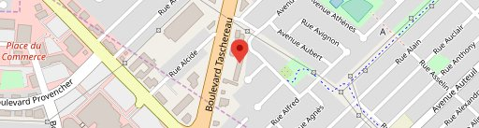 Figure 4 Chicken Curry

Figure 3 Restaurant's Map

Figure 5 Chicken Tikka on Sizzler

Figure 6 Shrimp Bhuna

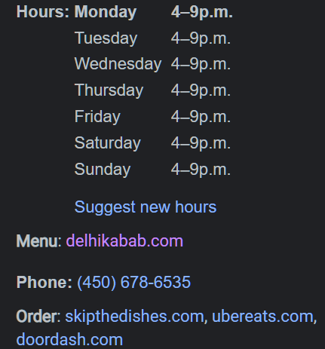

Figure 7 Opening Times and Delivery Partners

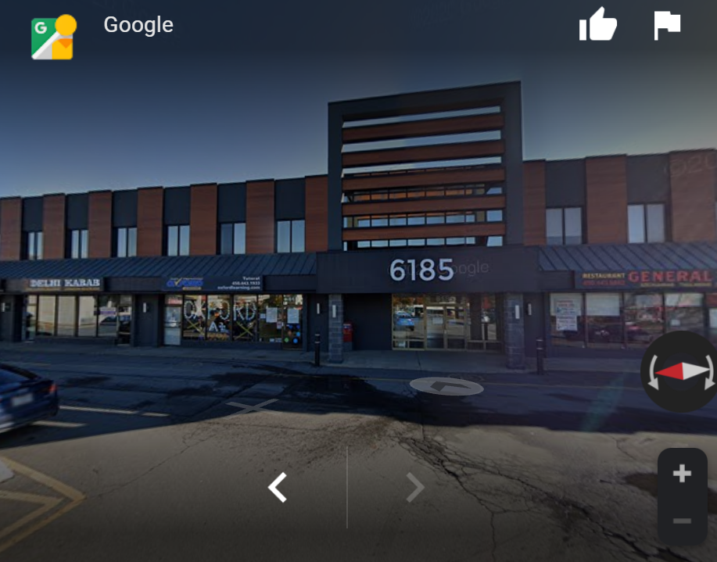 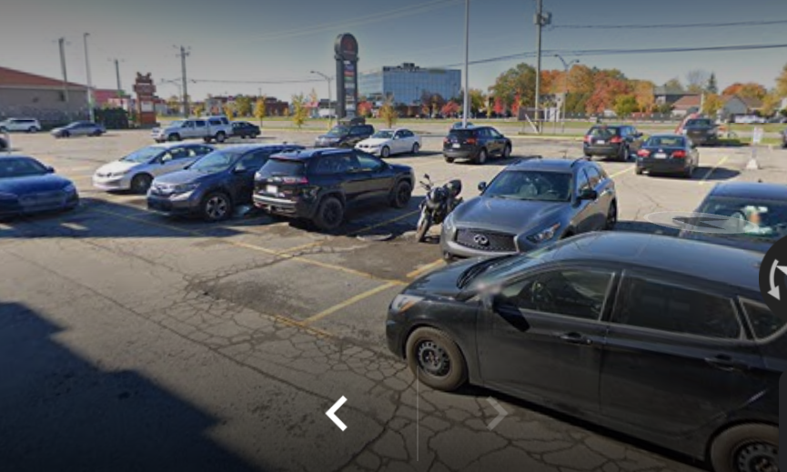

Figure 8 Strip Mall (Front View) Figure 9 Parking Space

**11. APPENDIX B: WEBSITE SCREENSHOTS**

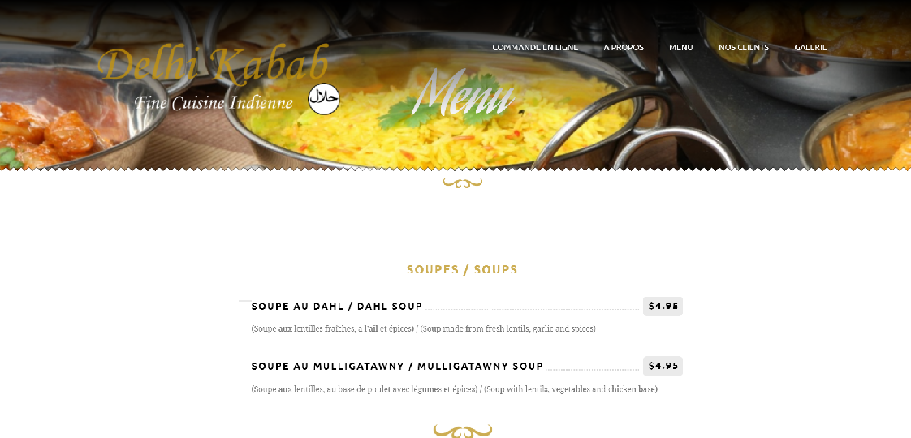

Figure 1 Main Menu

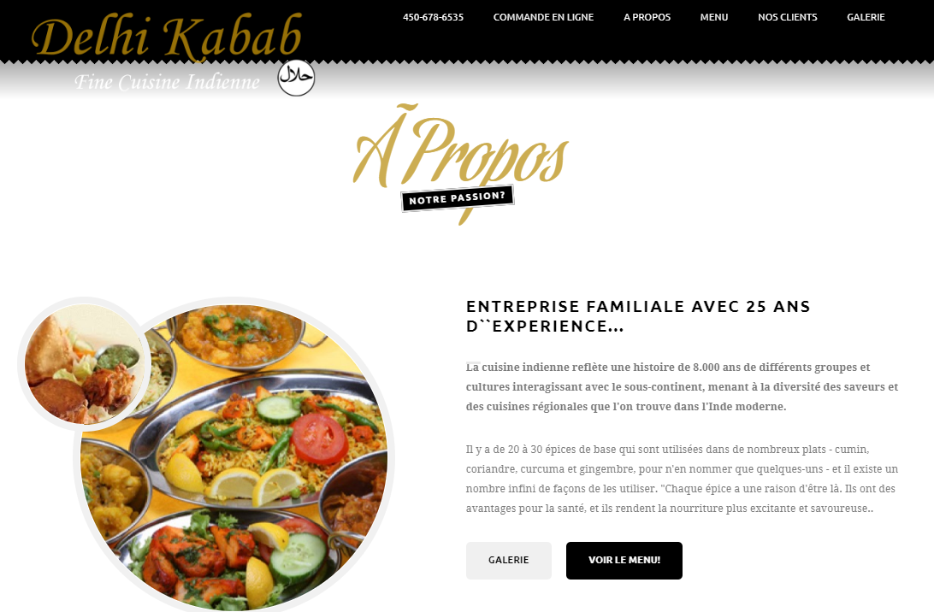

Figure 2 About Page

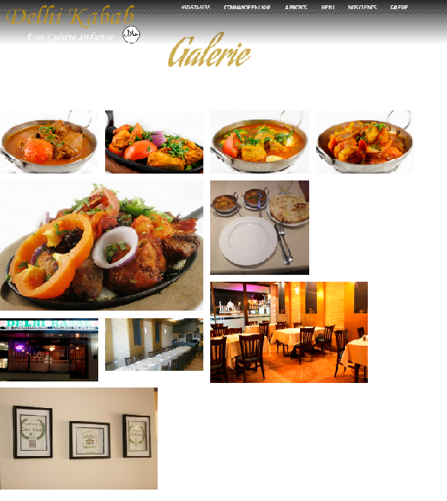

Figure 3 Gallery